**Lab 2**

**Question 1** (10 points) - Examine the Metadata for the World_Countries shapefile.

1. How accurate and/or up to date is this shapefile depicting the world’s countries?

World Countries shows generalized boundaries for the countries as they were in January 2008. Considering only two countries have been created after this time, this layer is extremely accurate, however, there have been minor border changes through war and dispute, in cases like Russia/Ukraine. I would still consider this layer to be at least 95% accurate.

1. What new countries have been created after this data were created?

Only Kosovo (2008) and South Sudan (2011) have been created after this 2008 layer.

**Question 2** (10 points) – Look at the attribute table, specifically the POP_CLASS and POP_RANK fields.

1. Which POP_RANK numbers do you need in order to select cities with greater than or equal to 1 million people?

You need a POP_RANK < 3 (or =< 2) to select a population of over 1,000,000.

b) What type of data is POP_RANK? Is it nominal, ordinal, interval or ratio?

I think this is an Ordinal Data type due to it’s rank based on population but only including the order in which they would come.

c) What about POP_CLASS?

I consider POP_CLASS Interval Data due to it giving both the order of the data values and the quantifiable space between them.

**Question 3** (4 points) – How many records were selected?

256 records were selected with the query.

**Question 4** (6 points) – Take a Screenshot of your new symbology. Include a caption.

Map including the new symbology of Major Cities differentiating cities with population over 5,000,000 and those in the 1,000,000 to 4,999,999 range:

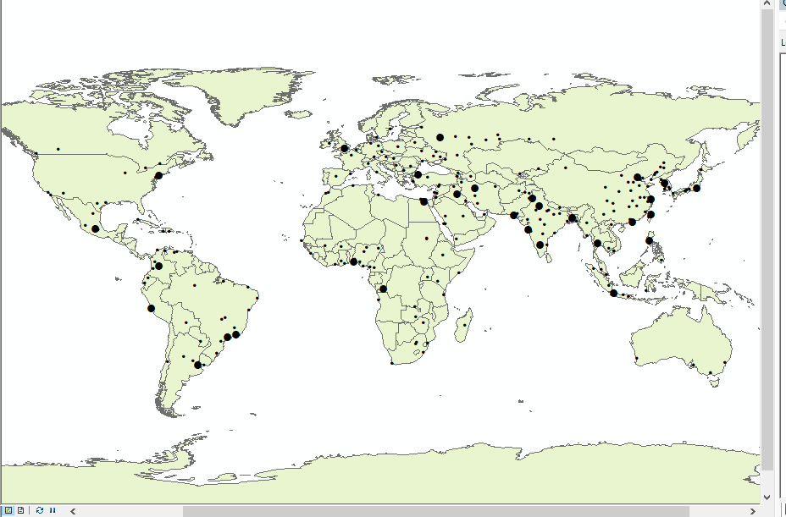

**Question 5** (6 points) – Take a Screenshot of your new labeling. Include a caption.

Map including the new labeling of Major cities with population over 5,000,000:

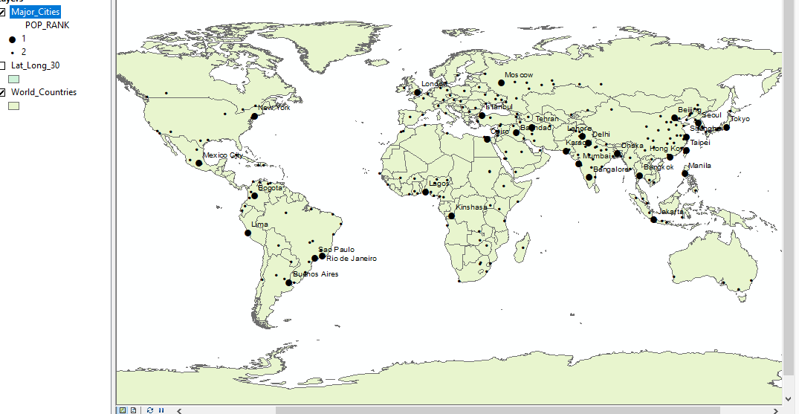

**Question 6** (8 points) – Take a Screenshot of your new symbology. Include a caption. In the screenshots caption, describe it the population density is: nominal, ordinal, interval, ratio?

Population Density in this map would best be described as Ratio considering we know the quantities of the classes, their order, the difference between them, and the ability to calculate ratios due to the fact that there can be a true zero populations – somewhere like Antarctica.

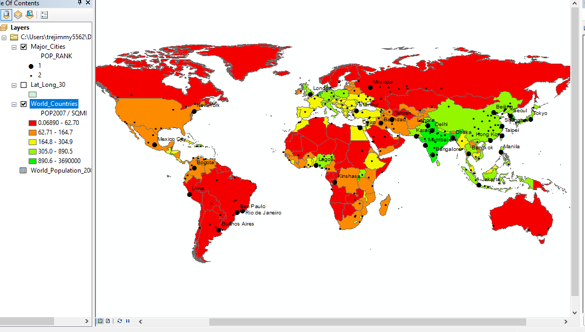

**Question 7** (6 points) – Take a Screenshot of your map with the new basemap. Include a caption.

Below is the finished map highlighting major cities by population and world countries with the same. It is imposed on the Oceans basemap for clarity of reading:

